

Facility Identification (facid) Plug-In Starter Kit
Installation and Administration Guide

EN-Node
.Net Version

Version: 1.0

December 23, 2011



1368 How Lane
North Brunswick, New Jersey 08902
www.enfotech.com

Revision History
Version | Date | Created By | Reviewed By | Description
1.0 | 12/21/2011 | Charlie Tsai |  | Release for public use

Tables of Contents

1 Document Purpose 4
2 Plug-In Overview 4
3 Installing the Plug-In 4
3.1 Prerequisites 4
3.2 Installation Package Contents 4
3.3 Installation Instructions 4
4 Testing the Plug-in 7
4.1 Test GetTransactionList Query 7
4.2 Test GetTransactionDetail Query 8

Document Purpose
The purpose of this document is to provide guidance on the setup, use, and maintenance of the EN-Node Facility Identification (FACID) Plug-ins.
Facility Identification Services allow users to search and analyze facility information from FACID staging Database. The XML generated by the Plug-In is compliance with FACID_v3.0 schema.

Plug-In Overview
Two different FACID plug-ins are available under the FACID data flow:
- GetFacilityByChangeDate: A Query service that provides a listing of facility information meeting specific search criteria
- GetFacilityByChangeDate: A Solicit service that provides a listing of facility information meeting specific search criteria

Installing the Plug-In

Prerequisites
- EN-Node has been installed
- Existing Oracle Database is installed.

Installation Package Contents
This section identifies the files that are provided as part of the FACID Plug-In Installation Package. The FACID Plug-In Installation Package includes the following:

- GetFacilityByChangeDateQuery_DataWizardConfig.xml: Node Plug-In Configuration file that defines the step-by-step logic for the GetFacilityByChangeDate Query
- GetFacilityByChangeDateSolicit_DataWizardConfig.xml: Node Plug-In Configuration file that defines the step-by-step logic for the GetFacilityByChangeDate Solicit
- GENERATE_FACID_V3_STG.sql: The script will create staging database, tables, store procedure for the plug-in.

Installation Instructions
To create and configure the FACID Node Plug-Ins please follow these steps:

- Run the following scripts using Oracle SQL deveoper:
  - GENERATE_FACID_V3_STG.sql
- Update the two …Wizard.xml files with your state or tribe specific database connection information:

  - Correct the connection string to point to your EN-Node data source:
<parameter name="dataSource" value="MSSQL:server=xxxxx; database=xxxxx;UID=xxxxx; password=xxxxx;" type="System.String" />

- Create the GetFacilityByChangeDate Query Operation:
  - Log into the Node Administration Console. Under the Node Domains webpart, and click the “Go to Operations” link for the Node Domain
  - Click the “Create Operation by XML” button
  - Click Browse and select the GetFacilityByChangeDateQuery_DataWizardConfig.xml from the package.

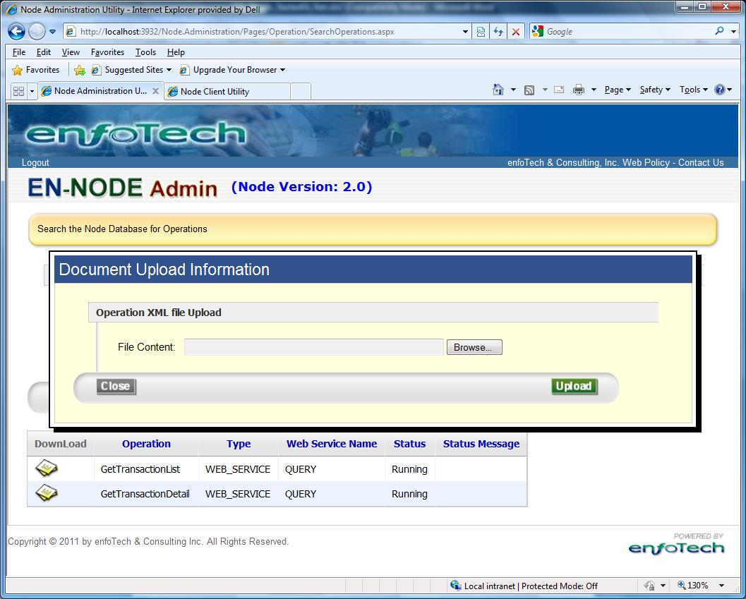

  - Click Upload to Create the GetFacilityByChangeDate Operation.
  - The following information should be displayed in the operation information section:
    - Operation Name: GetFaciltyByChangeDate
    - Operation Type: Web Service
    - Web Service: Query
  - The follow parameters should be listed:
    - Change Date
    - Originating Partner Name
    - Information System Acronym Name

- Create GetFacilityByChangeDate Solicit Operation:
  - Log into the Node Administration Console. Under the Node Domains webpart, and click the “Go to Operations” link for the Node Domain
  - Click the “Create Operation by XML” button
  - Click Browse and select the GetFacilityByChangeDateSolicit_DataWizardConfig.xml from the package.
  - Click Upload to Create the GetFacilityByChangeDate Operation.
  - The following information should be displayed in the operation information section:
    - Operation Name: GetFaciltyByChangeDate
    - Operation Type: Web Service
    - Web Service: Solicit
  - The follow parameters should be listed:
    - Change Date
    - Originating Partner Name
    - Information System Acronym Name

Testing the Plug-in

Test GetTransactionList Query

Step 1: Authenticate to your node
First authenticate to your node using the Node Client tool:
- Node Address: Provide your Node endpoint
- User Name: Enter your NAAS username
- Password: Enter your NAAS password
- Then click the Authenticate button
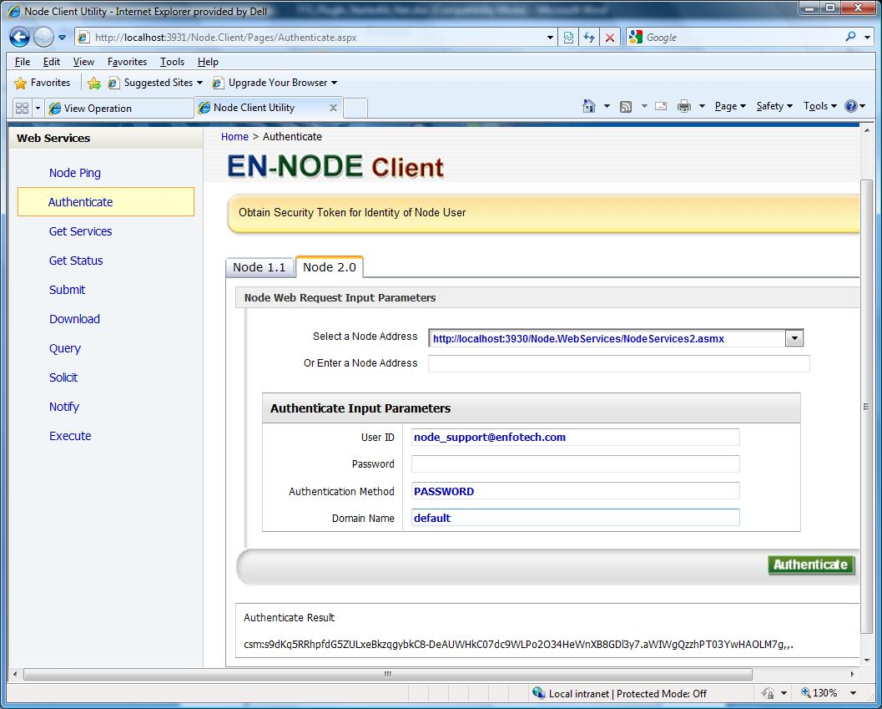

The Result should show a security token similar to the one above.

Step 2: Call GetFacilityByChange Query
Click on the Query link on the left menu to query data from your Node. Fill in the following information:
- Security Token: should be automatically populated from the step above
- Request Name: GetFacilityByChangeDate
- Parameters:
  - Change Date: in format YYYY/MM/DD (required Field)
  - Originating Partner Name: (empty)
  - Information System Acronym Name: (empty)

You should receive the following XML results as depicted below:
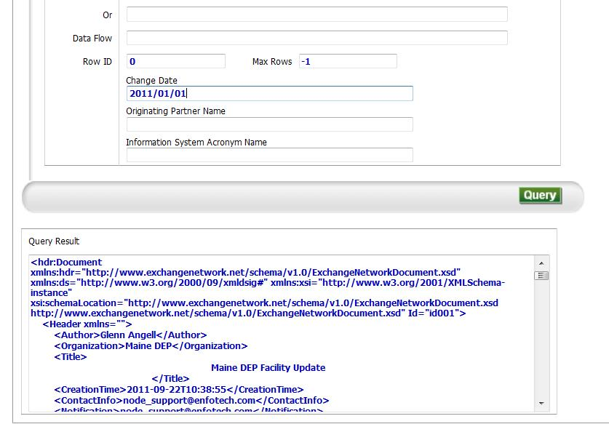

Test GetFacilityByChangeDate Solicit

Step 1: Authenticate to your node
First authenticate to your node using the Node Client tool:
- Node Address: Provide your Node endpoint
- User Name: Enter your NAAS username
- Password: Enter your NAAS password
- Then click the Authenticate button

Step 2: Call GetFacilityByChange Solicit
Click on the Solicit link on the left menu to solicit data from your Node. Fill in the following information:
- Security Token: should be automatically populated from the step above
- Request Name: GetFacilityByChangeDate
- Parameters:
  - Change Date: in format YYYY/MM/DD (required Field)
  - Originating Partner Name: (empty)
  - Information System Acronym Name: (empty)

You should receive the following XML results as depicted below:
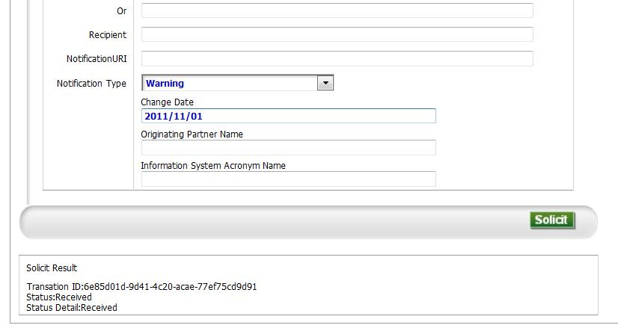
Step 3: Call GetStatus to check solicit result
Click on the GetStatus link on the left menu to check the solicit result from your Node. Fill in the following information:
- Security Token: should be automatically populated from the step above
- Transaction ID: copy from step 2 result.

You should receive the following results as depicted below:

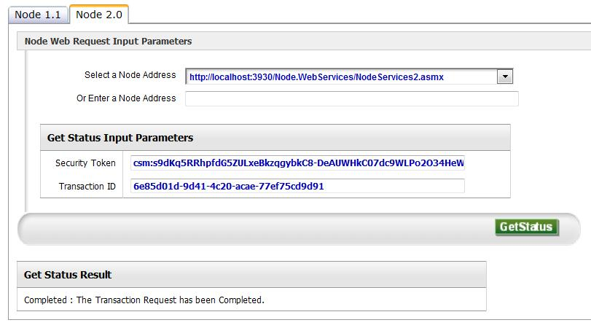
Step 4: Call Download to retrieve solicit result
Execute the Step If the result of GetStatus is Completed.
Click on the Download link on the left menu to download the solicit result from your Node. Fill in the following information:
- Security Token: should be automatically populated from the step above
- Transaction ID: copy from step 2 result.

You should receive the following results as depicted below:

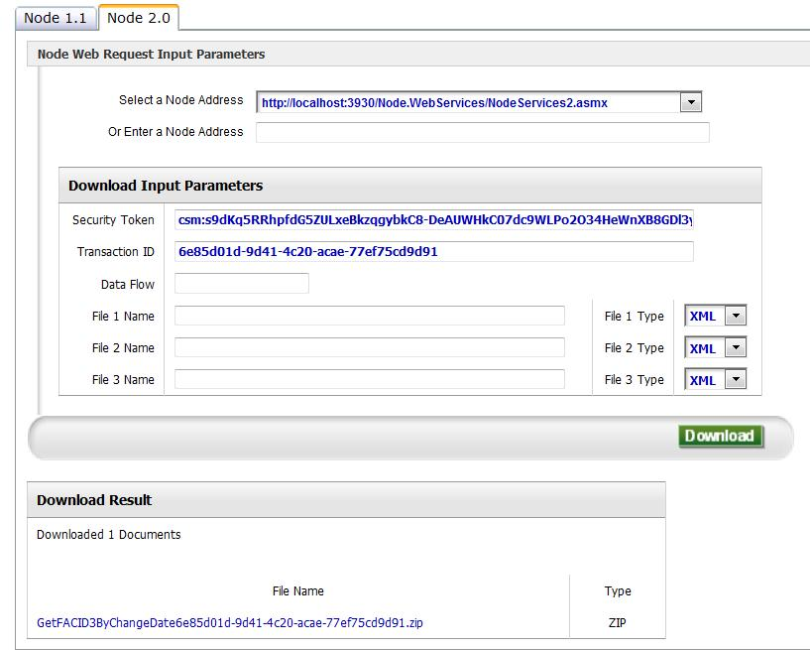
Click the File Link to download the file.

